CIS241 Final Project – Site Specifications

Rebecca Johnston

**Home Page** *(1/5)***:**

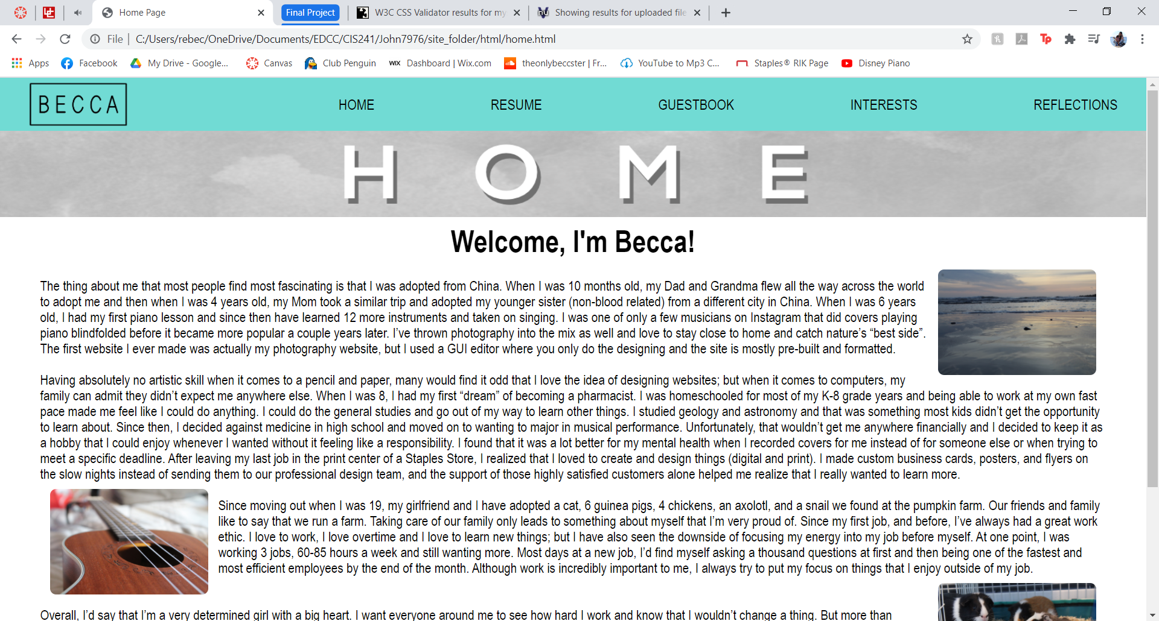

The purpose of this page is to introduce the reader to who I am as a person. They will get to know me, my interests, and background. It’s always helpful for people to be able to connect to the person behind the webpage.

It also includes a few photos as a visual representation of some of the things that I am passionate about and the things that are a large part of my life; like my pets and instruments.

**Resume Page** *(2/5)***:**

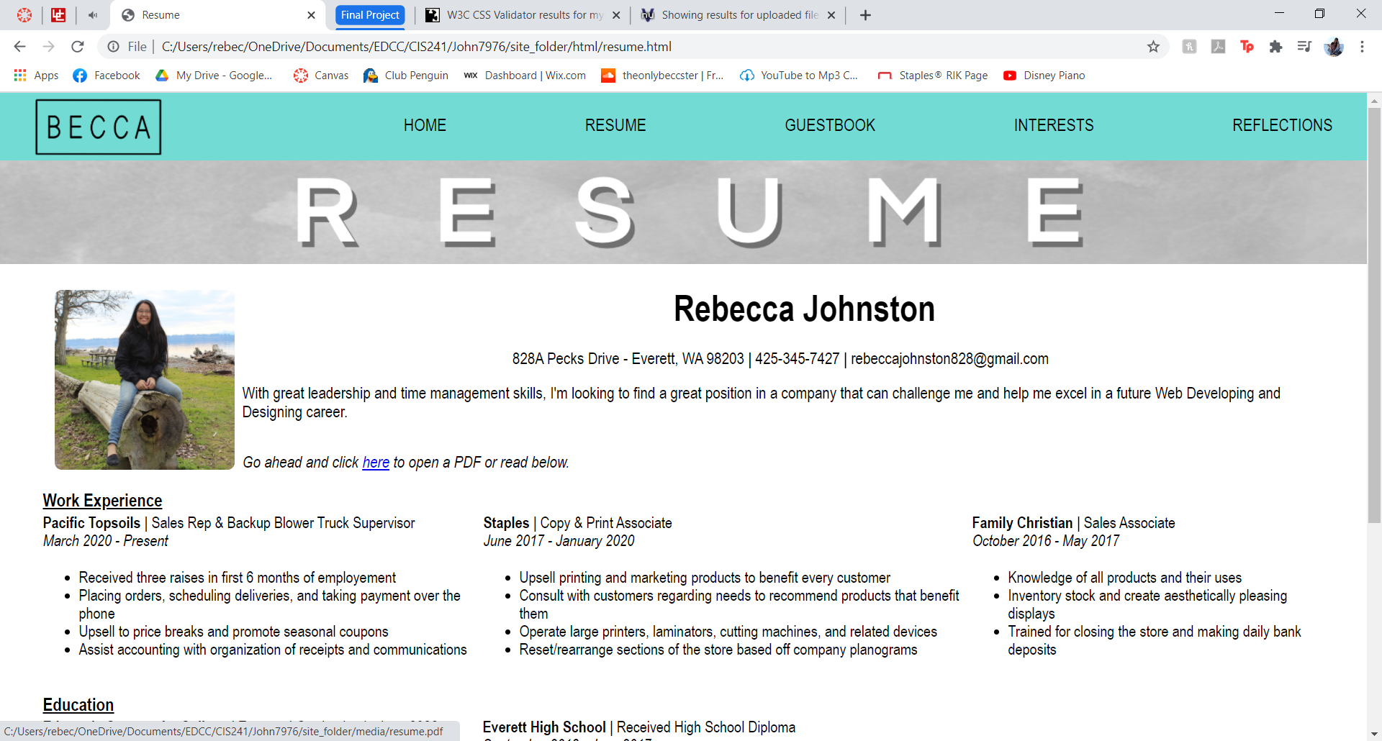

The purpose of this page is to show my accomplishments and display my employment history and current/past school accomplishments. This page also highlights descriptions of my skills and states my objective for seeking out a new job.

You will have the option to download a more appealing version of my resume as a PDF.

**Guestbook Page** *(3/5)***:**

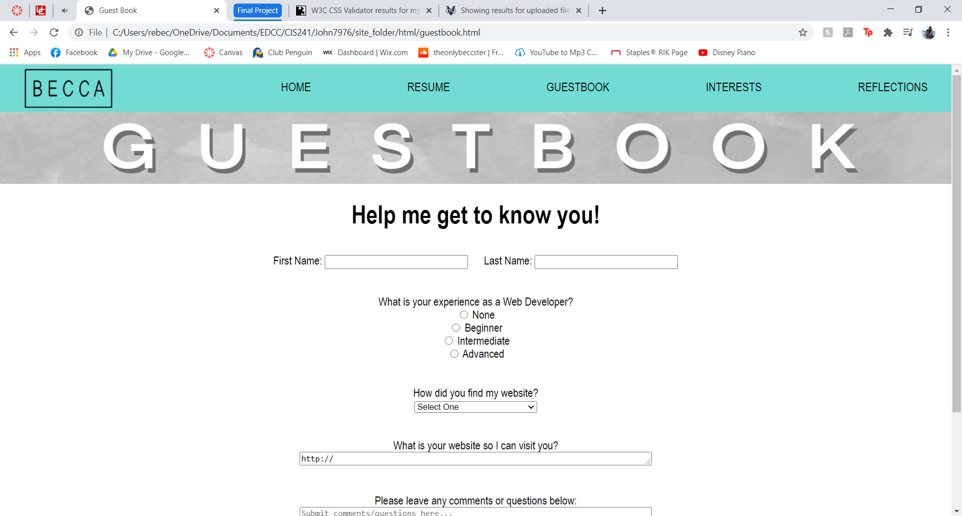

The purpose of this page is to get to know the visitors of the website. Find out who they are, how they found my website, and leave any comments or questions. They can also leave a link to their site so I can connect with them too.

A comments section is always a great way to find what people do and don’t like and help you know how and where you can improve. It also allows you to get a better understanding of how people found you or heard of you.

This form is easy to understand, simple and not too long that it will deter a visitor from completing it.

**Interests Page** *(4/5)***:**

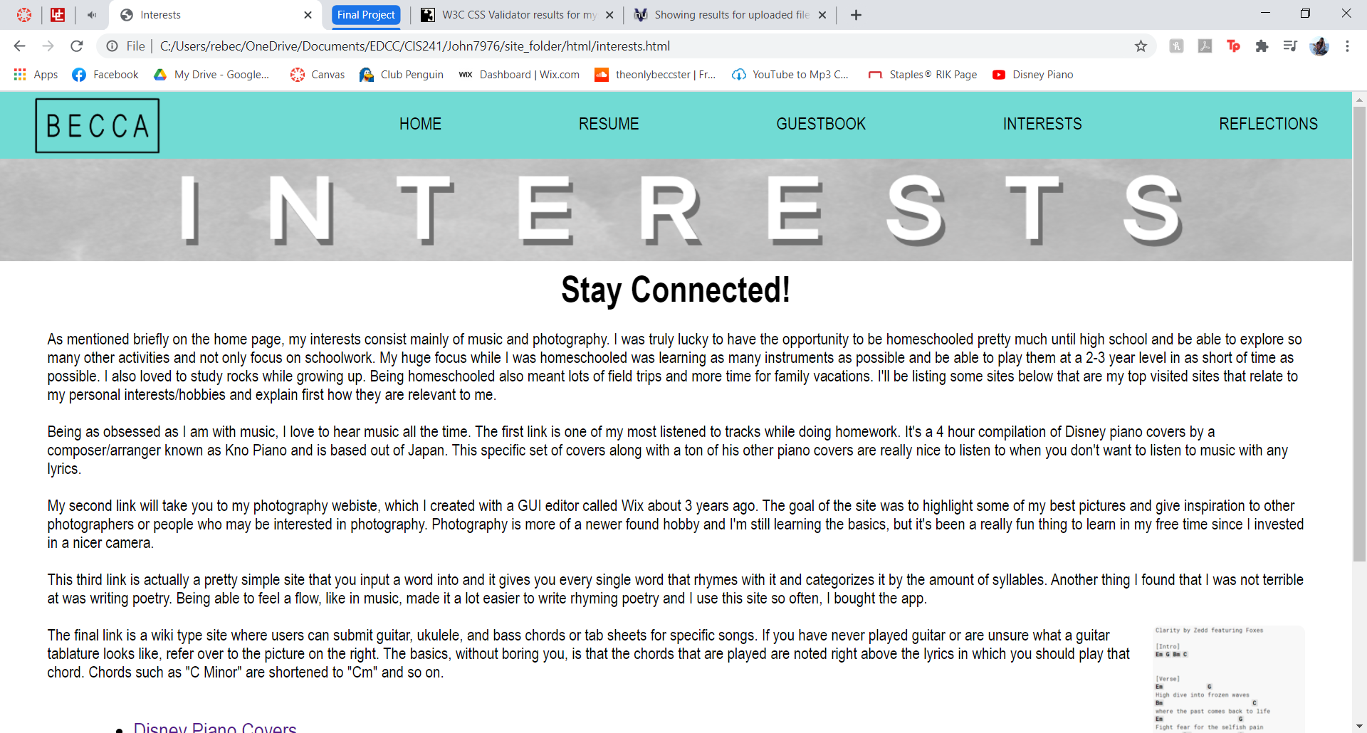

This page of my website really showcases what I love and what inspires me. These are the things that I do in my free time and are things I am passionate about. This is always important to have in any website, whether it be for a company or single person, because It helps the reader connect to the creator(s). It gives people the opportunity to relate to things we have in common.

At the bottom, it also includes active links to websites that relate to the interests I mention above. These links are things that I use all the time, or that are important to me. They will be listed in an organized list that is easy to read and navigate.

All links will open in a new tab so that it will be easy to continue exploring my site if needed.

**Reflections Page** *(5/5)***:**

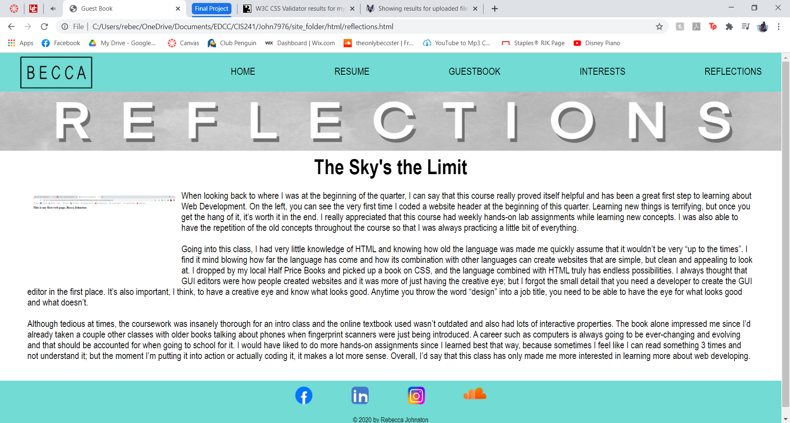

Throughout this final page, I describe what my perspective of this first class was. I talk about my level of knowledge before versus after the class and why I thought this class was such an important step to getting where I want to be.

The purpose of this is to show what I have learned and my growth. I will explain my thoughts and feelings along with my strengths and weaknesses throughout the class and how I improved. I think it is so important to show your growth and notice how far you can go in such a short amount of time. Most people coming out of high school don’t believe how far you can expand your knowledge in such a short amount of time.